#### Midterm – Git Merge Conflict: 3-way Merge

# Assignment Goal:

This assignment will familiarize you with git merge conflicts and their resolutions using a 3-way-merge.

The major steps in this assignment are:

* adding a new branch with one commit
* adding a commit to the master that modifies the same portion of of a file that was modified in the branch
* merging the branch into master resulting in a conflict
* resolving the merge conflict using the 3-way-merge

**Resolution Screenshots:**

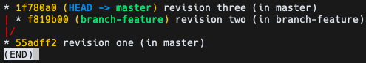

Figure 1: GIT_VISUALIZATION_ALL_BRANCHES after completing Step 3

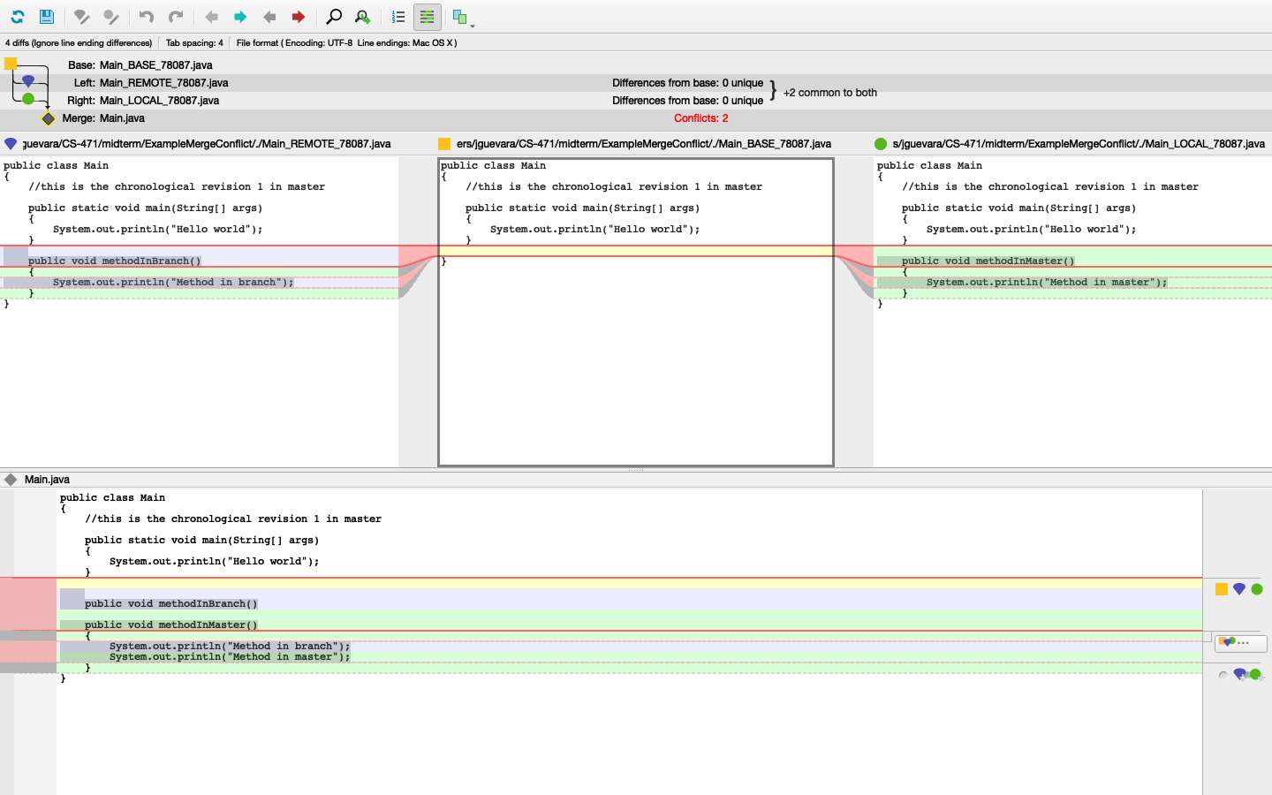

Figure 2: GIT_MERGE_CONFLICT_VISUALIZATION after completing Step 5

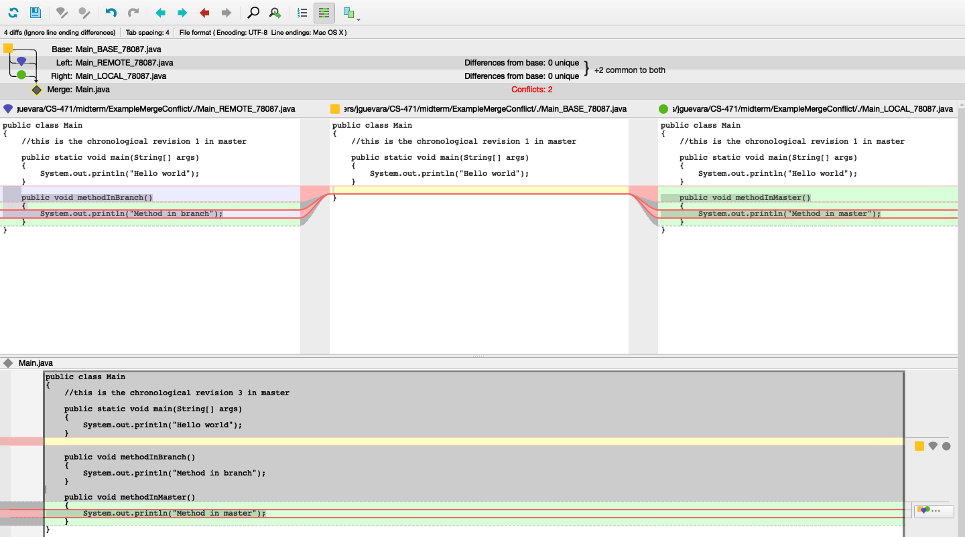

Figure 3: GIT_MERGE_CONFLICT_VISUALIZATION after completing Step 6

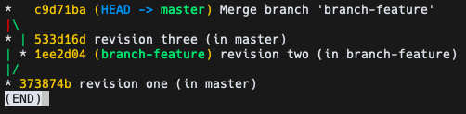

Figure 4: GIT_VISUALIZATION_ALL_BRANCHES after completing Step 8

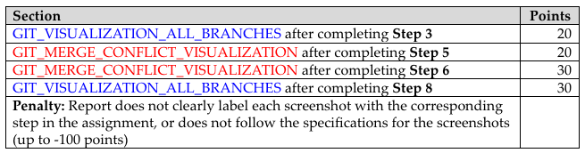**Grading Rubric:**